Configuring Locus Map Pro with Live Tracking Subscription

1. Start an app
2. Go to Main menu and Locus Store  
   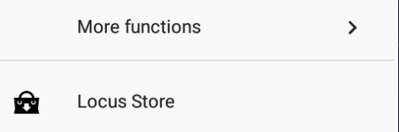
3. Select Features  
   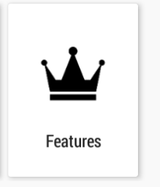
4. Select Live tracking Premium  
   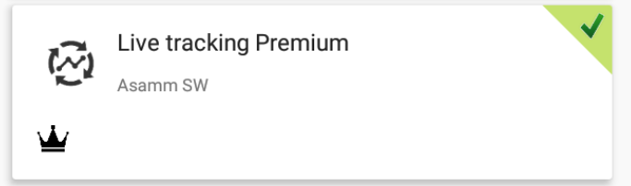
5. Buy a subscription with LoCoins.
6. Go Back to Live Tracking from Map Screen  
   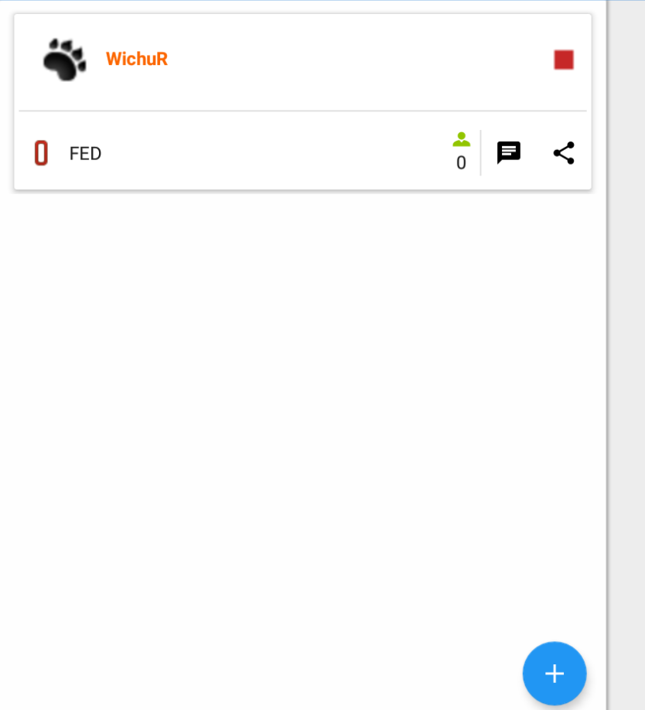
7. Click Plus +
8. Share with a new group  
   
9. Select icon, name, settings and optionally password. Click Add  
   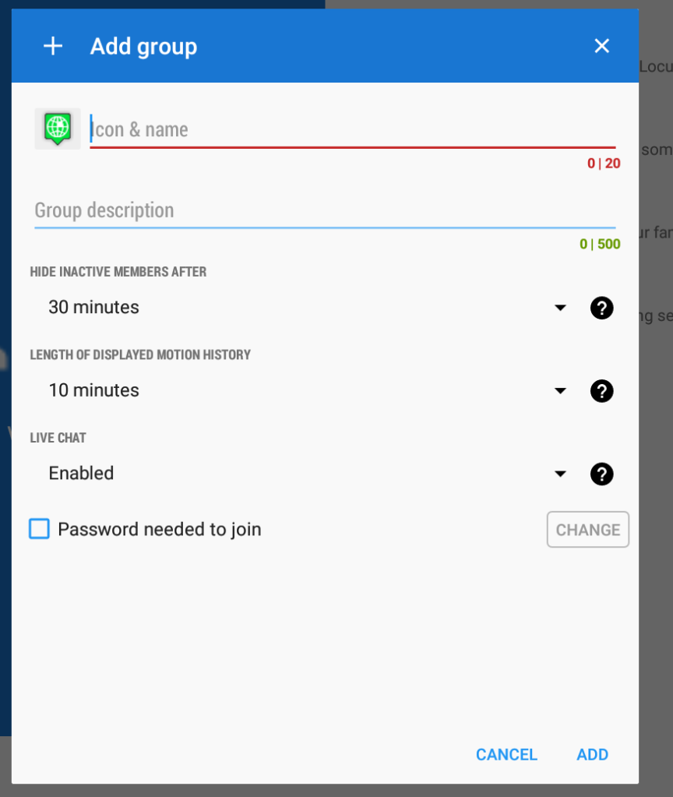
10. Set how others will see you and click Next  
    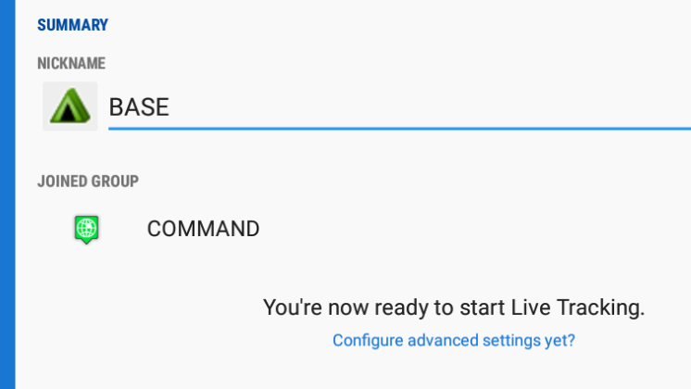
11. Kliknij nazwę Grupy COMMAND  
    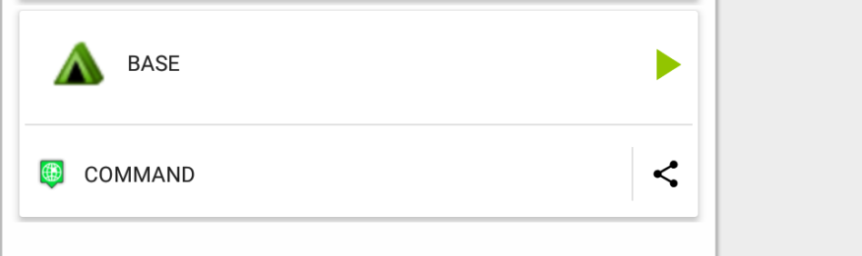
12. Select Manage
13. Click Add and select Add own  
    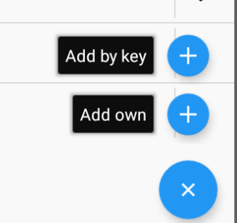
14. Create a room and configure it  
    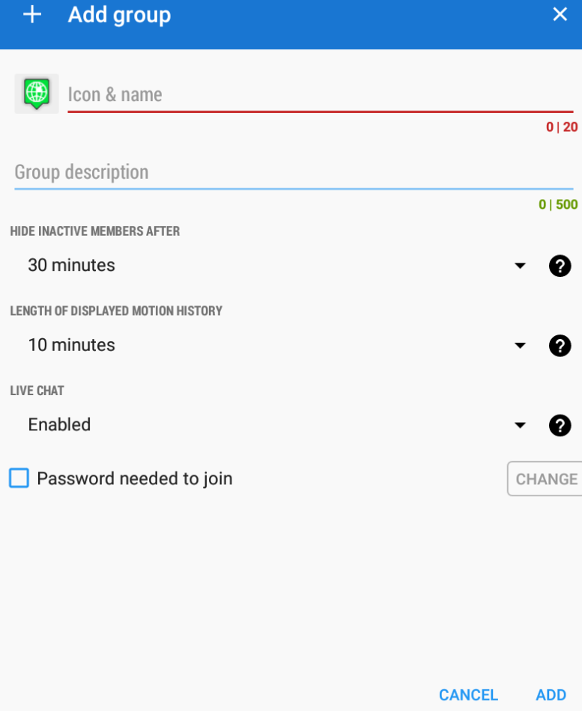
15. Go back to Live Tracking
16. That is what you should see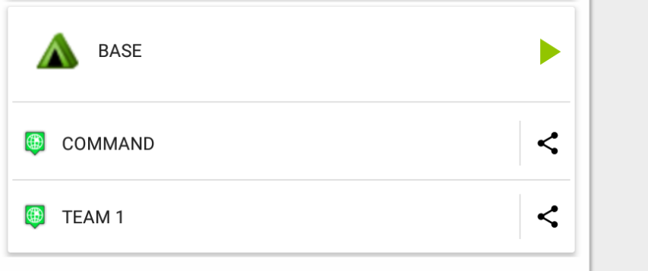
17. Click green triangle to enter all rooms  
    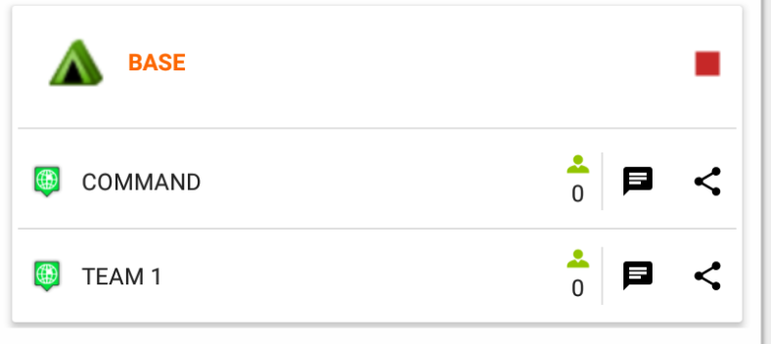
18. Share icons allow you to give access keys to other people  
    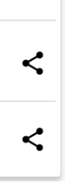
19. People will be asked for password if it is set
20. You can change password if you want stop new people from joining in
21. Click room name and select Manage   
    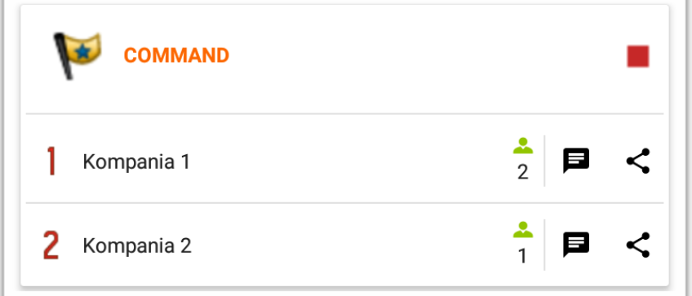
22. Click three dots and Edit option  
    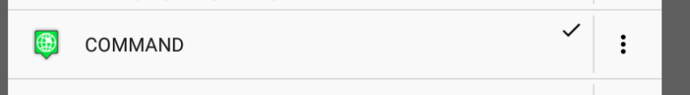
23. Change password  
    
24. If you are in many rooms you can switch in chat  
    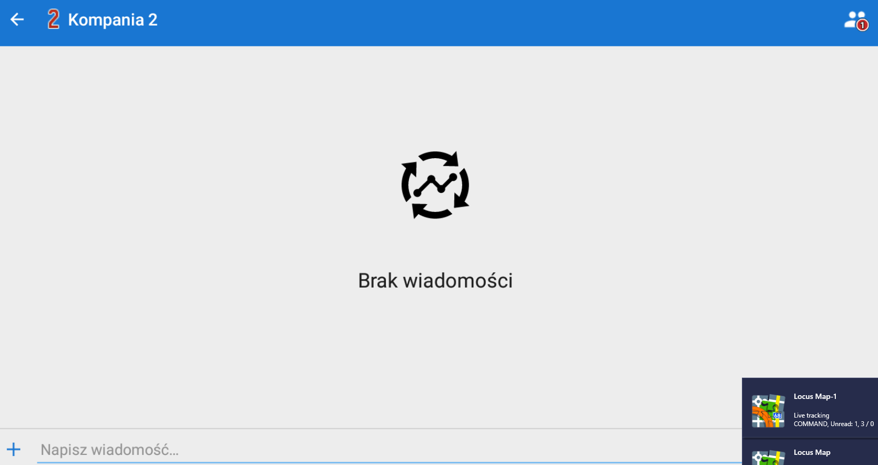
25. Number in red circle shows the number of messages in other rooms waiting for you.  
    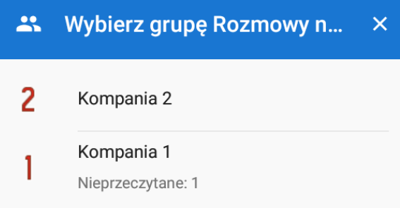
26. 